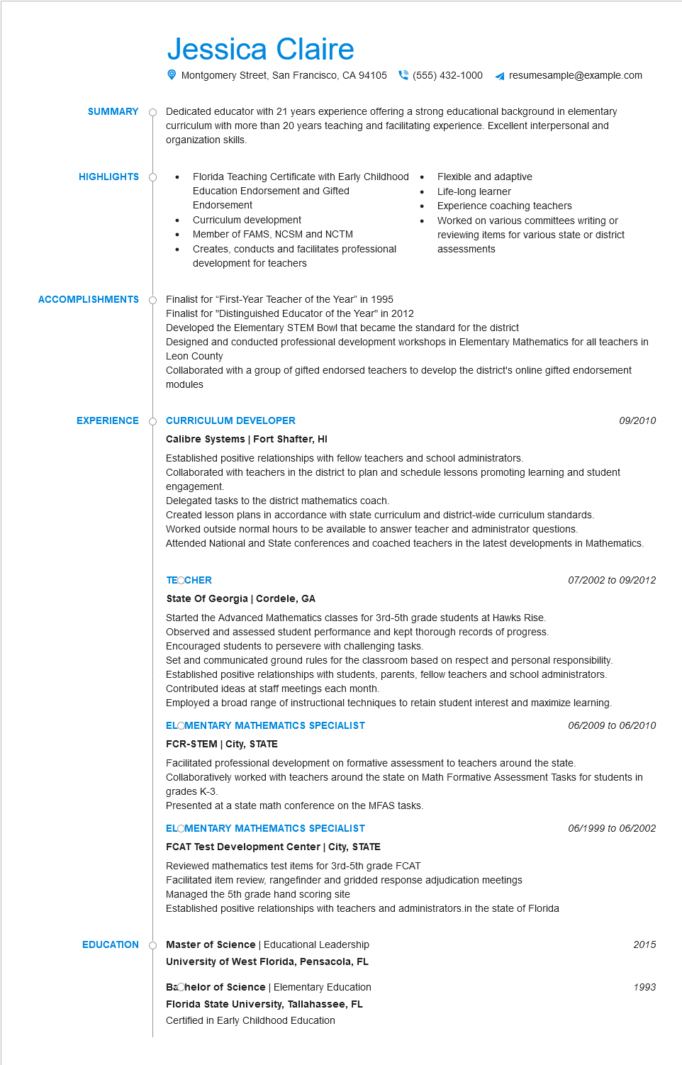
SUMMARY
HIGHLIGHTS
Jessica Claire
Montgomery Street, San Francisco, CA 94105(555) 432-1000
resumesample@example.com
Dedicated educator with 21 years experience offering a strong educational background in elementary curriculum with more than 20 years teaching and facilitating experience. Excellent interpersonal and organization skills.
•
•
Florida Teaching Certificate with Early Childhood
Education Endorsement and Gifted
Endorsement
Curriculum development
Member of FAMS, NCSM and NCTM
Creates, conducts and facilitates professional development for teachers
Flexible and adaptive
Life-long learner
Experience coaching teachers
Worked on various committees writing or reviewing items for various state or district assessments
Finalist for "First-Year Teacher of the Year" in 1995
ACCOMPLISHMENTS
Finalist for "Distinguished Educator of the Year" in 2012
Developed the Elementary STEM Bowl that became the standard for the district
Designed and conducted professional development workshops in Elementary Mathematics for all teachers in Leon County
Collaborated with a group of gifted endorsed teachers to develop the district's online gifted endorsement modules
EXPERIENCE Ó CURRICULUM DEVELOPER
09/2010
Calibre Systems | Fort Shafter, HI
Established positive relationships with fellow teachers and school administrators.
Collaborated with teachers in the district to plan and schedule lessons promoting learning and student engagement.
Delegated tasks to the district mathematics coach.
Created lesson plans in accordance with state curriculum and district-wide curriculum standards.
Worked outside normal hours to be available to answer teacher and administrator questions.
Attended National and State conferences and coached teachers in the latest developments in Mathematics.
TEOCHER
State Of Georgia | Cordele, GA
Started the Advanced Mathematics classes for 3rd-5th grade students at Hawks Rise. Observed and assessed student performance and kept thorough records of progress. Encouraged students to persevere with challenging tasks.
07/2002 to 09/2012
Set and communicated ground rules for the classroom based on respect and personal responsibility. Established positive relationships with students, parents, fellow teachers and school administrators. Contributed ideas at staff meetings each month.
Employed a broad range of instructional techniques to retain student interest and maximize learning. ELOMENTARY MATHEMATICS SPECIALIST
06/2009 to 06/2010
FCR-STEM | City, STATE
Facilitated professional development on formative assessment to teachers around the state. Collaboratively worked with teachers around the state on Math Formative Assessment Tasks for students in grades K-3.
Presented at a state math conference on the MFAS tasks.
ELOMENTARY MATHEMATICS SPECIALIST
FCAT Test Development Center | City, STATE
Reviewed mathematics test items for 3rd-5th grade FCAT
Facilitated item review, rangefinder and gridded response adjudication meetings
Managed the 5th grade hand scoring site
Established positive relationships with teachers and administrators.in the state of Florida
EDUCATION
Master of Science | Educational Leadership
University of West Florida, Pensacola, FL
Bachelor of Science | Elementary Education
Florida State University, Tallahassee, FL Certified in Early Childhood Education
06/1999 to 06/2002
2015
1993

